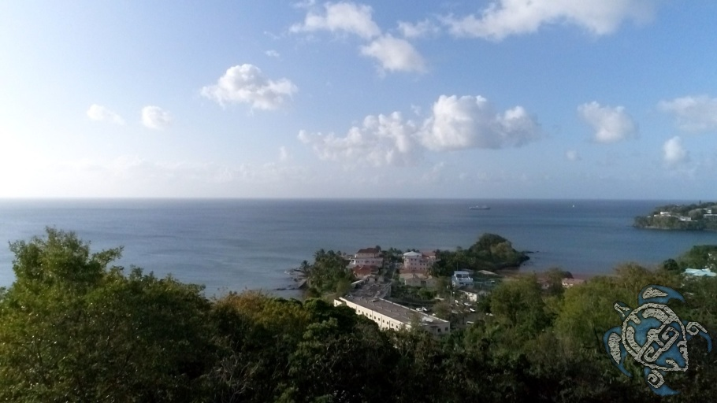
Just minutes south of Castries, La Toc is a venerable neighbourhood which has been the choice for spectacular residences and historical military barracks as far back as the 18th century, and since the 1950s has been home to one of the island's original and treasured tourism destinations, Bagshaws of Saint Lucia. In the past two decades, the area's property market has developed due to the arrival of Sandals La Toc Golf Resort & Spa, along with the island's first private hospital at Tapion and the modern Millennium Highway connecting to the south and west coast roads.
La Toc is also popular for its stunning views of Saint Lucia's northern coastline which are particularly beautiful from the hillside location of Villa Tick-Toc. A truly unique real estate opportunity, the property is also a fascinating story of one of the private development's first uniquely-designed and built homes, updated with a very modern aesthetic brought by its current owner, a high-end contractor and visionary where it comes to a new style of Caribbean architecture.
Perched above Sidney Bagshaws' original home, Villa Tick-Toc is just minutes from Castries and the highway, on a sloping lot which overlooks the entrance to Castries Harbour. Properties along the private road have access pedestrian to the La Toc Beach and the enclave boasts some of the area's most affluent, architecturally interesting homes.
The house was originally built in the 1990's by an Australian couple whose tropical wooden design was a personal vision come to life over a number of years. A quarter of a century later, the hillside home has undergone a radical reimagining by one of Saint Lucia's most innovative designer/contractors and nowadays Villa Tick-Toc draws gasps of attention from passers-by who are amazed by its ultra-modern exterior with its geometric balconies on three storeys accented by state-of-the-art steel cable fencing.
Inside, there is also enthusiastic approval from visitors who take a walk around the split-level villa with its elegant use of modern, practical materials like tempered glass with chrome, recycled materials in flooring and other finishes. The original two wooden storeys have been extended with a concrete addition below with independent access from the driveway which can be used as an office, perfect for the work-at-home professional.
